**Assignment 2: Create MFA for Authentication.**

1. Sign in to the **AWS Management Console**.

2. On the right side of the navigation bar, choose **account name**, and choose **Security credentials.**

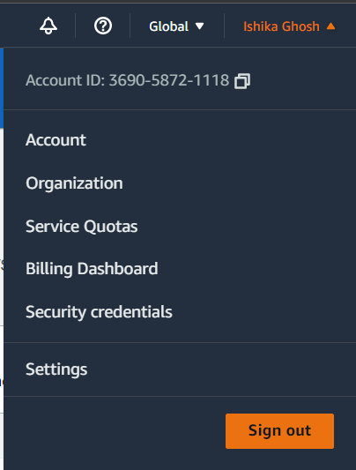

3. In the Multi-Factor Authentication (MFA) section, choose **Assign MFA device**.

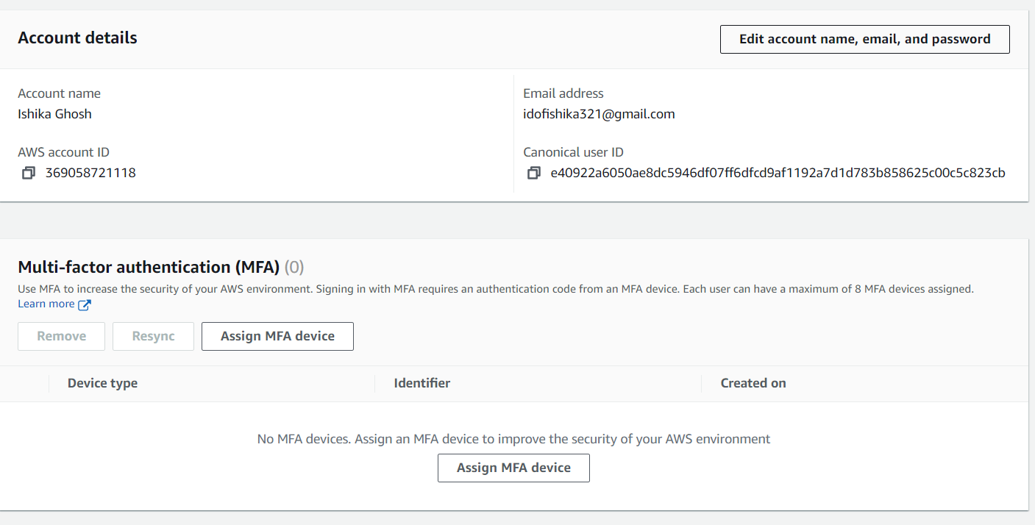

4. In the wizard, type a **Device name**, choose **Authenticator app**, and then choose **Next.**

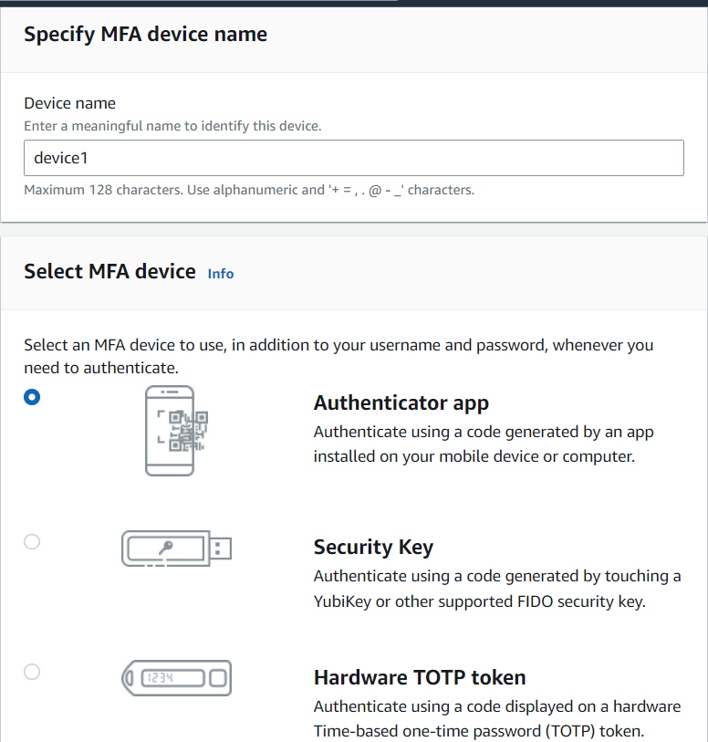

5. Open the virtual MFA app on the device.

* Scan the QR code. To use the QR code to configure the virtual MFA device, from the wizard, choose Show QR code. Then follow the app instructions for scanning the code.
* In the Set up device wizard, choose Show secret key, and then type the secret key into the MFA app.
* The device starts generating six-digit numbers.

6. In the wizard, in the MFA code 1 box, type the one-time password that currently appears in the virtual MFA device. Wait up to 30 seconds for the device to generate a new one-time password. Then type the second onetime password into the MFA code 2 box. Choose Add MFA.

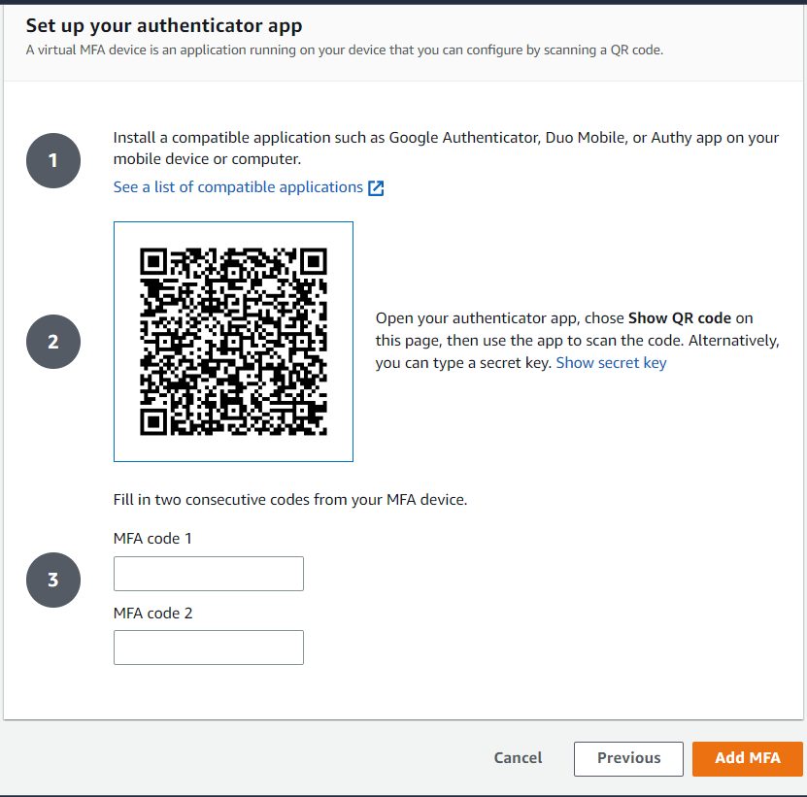

**The device is ready for use with AWS**

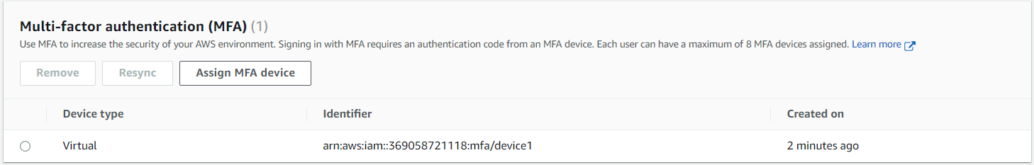

**Assignment3:Create IAM user giving full access of S3**

1. Sign in to the AWS Management Console and open the **IAM console**.

2. In the navigation pane, choose Users and then choose **Add user**.

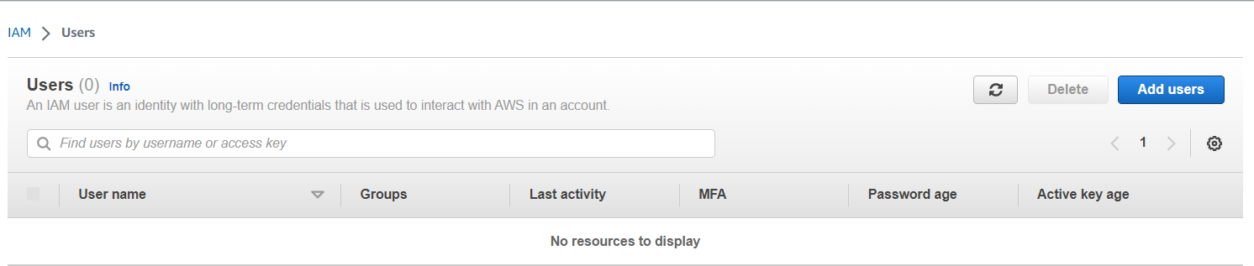

3. Type the user name for the **new user**. This is the sign-in name for **AWS**.